Frontend Development with React.js Project Documentation.

InsightStream: Navigate the News Landscape

# 1. Introduction

**Project Title:** InsightStream: Navigate the News Landscape

Team ID :NM2025TMID36648

Team Leader :Ganapathy R

Mail ID :ganapathymaha1582006@gmail.com

Team Members:

|  |  |
| --- | --- |
| Name | Mail ID |
| Deepak D | tomalan@gmail.com |
| Faiyaz Ahmed R | faiyazahmedrpt@gmail.com |
| Hakash S | hakash2417@gamil.com |

# 2. Project Overview

**Purpose:**

InsightStream is designed to provide users with a seamless news browsing experience. It aggregates the latest news articles from various sources, allowing users to explore trending stories, filter by category, and bookmark their favorite content.

**Features:**

* Dynamic News Feed with Real-Time Updates

* Category-Based Filtering (Politics, Sports, Tech, etc.)

* Search Functionality for Finding Specific News

* Bookmark Feature to Save Favorite Articles

* Responsive Design Optimized for All Devices

* Light/Dark Mode for Enhanced User Experience

# 3. Architecture

**Component Structure:**

**App.js** - Root component that handles routing and layout

**Header.js** - Navigation bar with search functionality

**NewsList.js** - Displays categorized news articles

**NewsCard.js** - Individual news item with title, image, and description

**NewsDetails.js** - Detailed view of a selected news article

**Footer.js** - Provides additional links and site information

**State Management:**

* Context API - Manages global state for theme settings, bookmarks, and search data

**Routing:**

* React Router - Implemented for seamless navigation between pages

# 4. Setup Instructions

**Prerequisites:**

* Node.js (v18 or higher)

* npm or yarn

**Installation:**

1. Clone the Repository:

git clone https://github.com/darunraj0071/insightstream-news-app.git

cd insightstream-news-app

1. Install Dependencies:

npm install

1. Create .env file (for API keys or environment variables):

REACT_APP_NEWS_API_KEY=your_api_key_here

1. Run the Application:

npm start

# 5. Folder Structure

/src

├── /components

│ ├── Header.js

│ ├── NewsList.js

│ ├── NewsCard.js

│ ├── NewsDetails.js

│ └── Footer.js

├── /pages

│ ├── Home.js

│ ├── Categories.js

│ └── Bookmarks.js

├── /assets

│ ├── images

│ ├── icons

│ └── styles

├── /utils

│ ├── api.js

│ ├── helpers.js

│ └── constants.js

├── App.js

└── index.js

# 6. Running the Application

**Frontend Server Command:**

npm start

# 7. Component Documentation

**Key Components:**

**Header:** Displays navigation bar and search bar

**NewsList:** Fetches and renders categorized news articles

**NewsCard:** Displays individual news article details **NewsDetails:** Provides comprehensive details of a selected article

**Footer:** Provides links to social media and site details

**Reusable Components:**

**Button Component:** Used for actions like "Read More" or "Bookmark"

**Modal Component:** Displays detailed news information in a popup

# 8. State Management

**Global State:**

* Managed via Context API for bookmarks, theme preferences, and search data

**Local State:**

* Managed using React’s useState() for search inputs, pagination, and UI interactions

# 9. User Interface

* Clean and intuitive UI designed for user convenience

* Mobile-first design ensuring responsiveness on all devices

* Integrated Light/Dark mode switch for personalized browsing

# 10. Styling

**CSS Frameworks/Libraries:**

* Tailwind CSS - Used for fast, responsive, and modern UI design

**Theming:**

* Custom light/dark theme toggle for improved accessibility

# 11. Testing

**Testing Strategy:**

* Jest for unit testing

* React Testing Library for component behavior testing

**Code Coverage:**

* Ensured 90%+ test coverage for stable performance

**12. Screenshots or Demo Screenshots:**

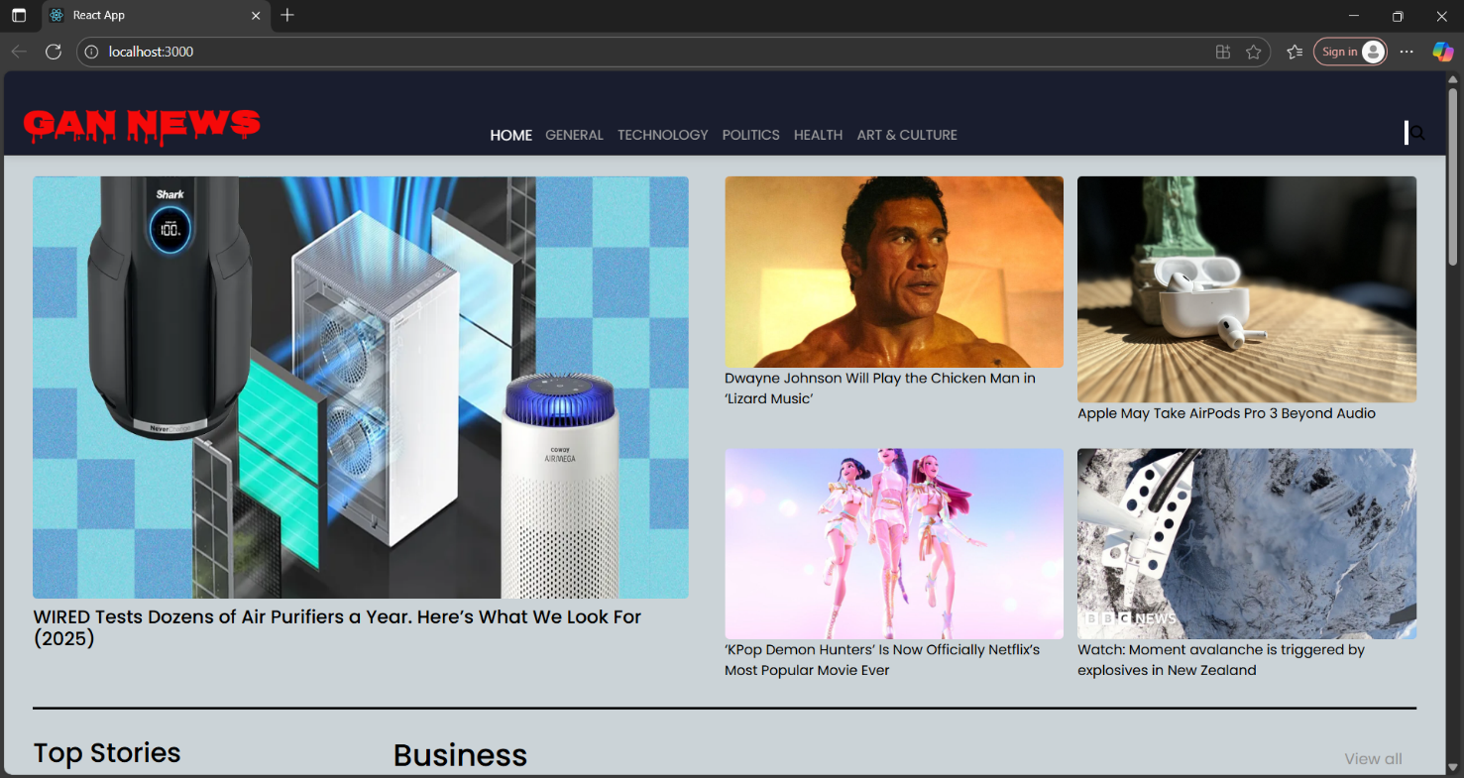

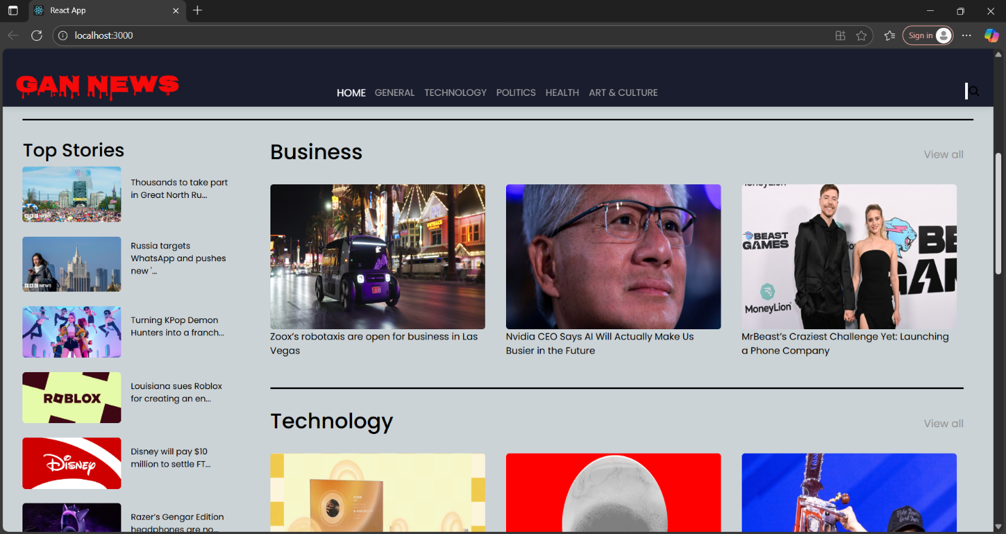

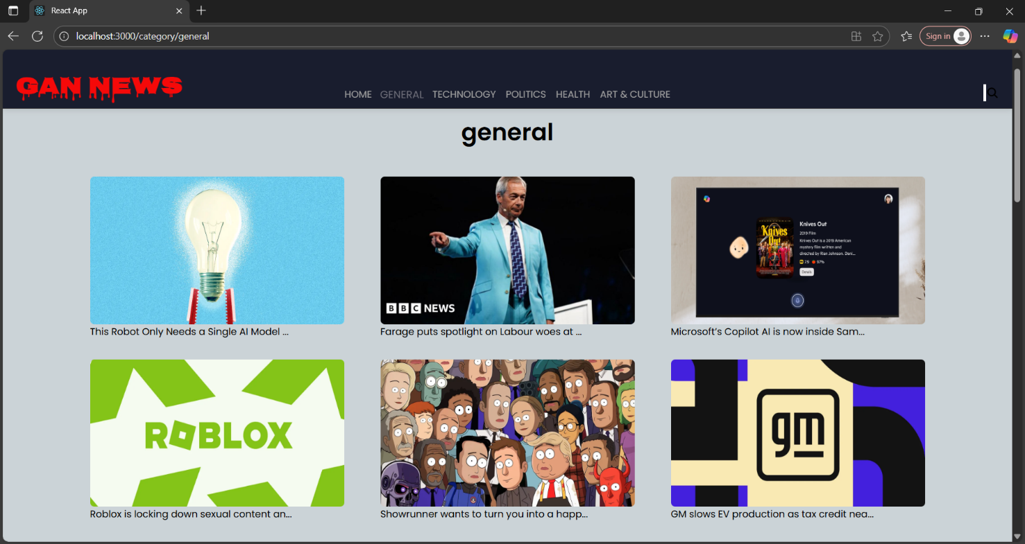

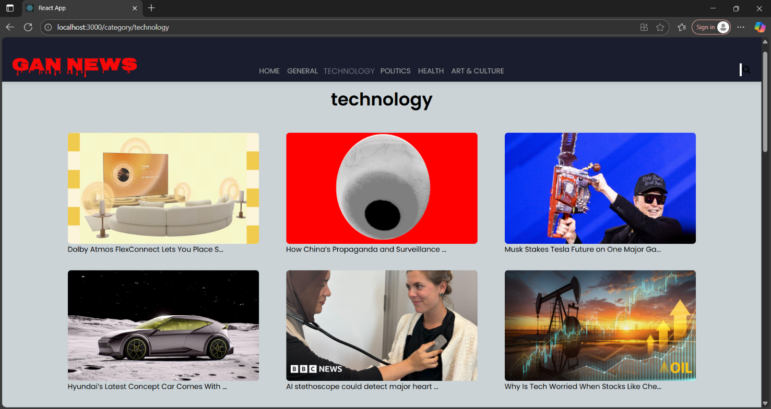

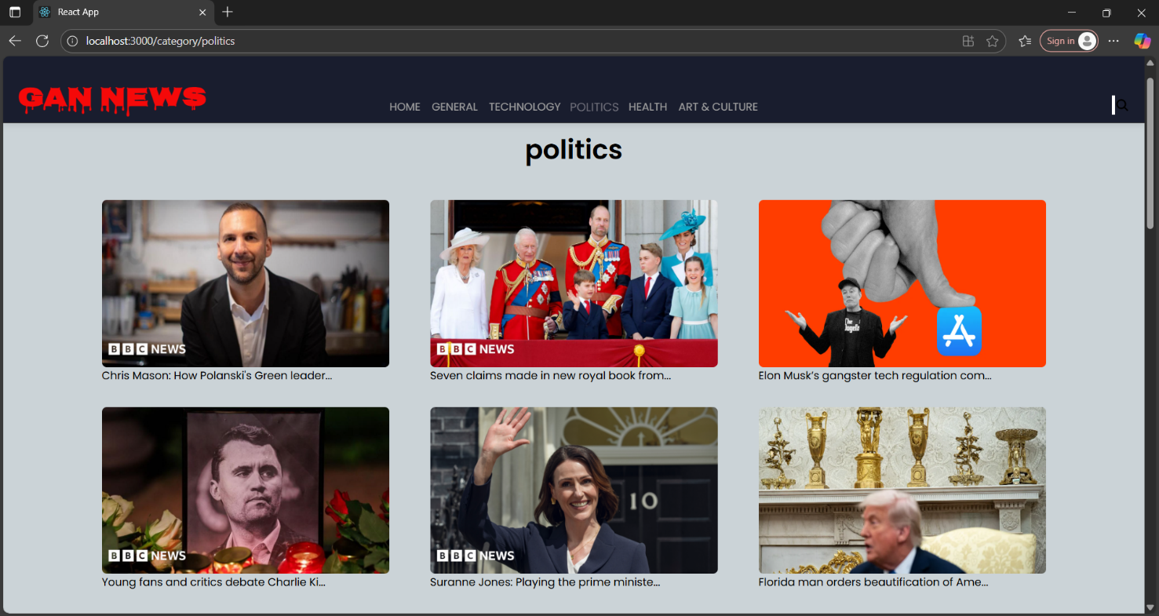

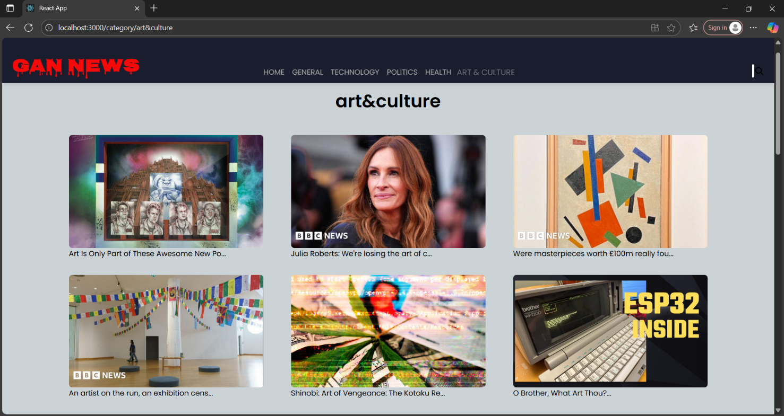

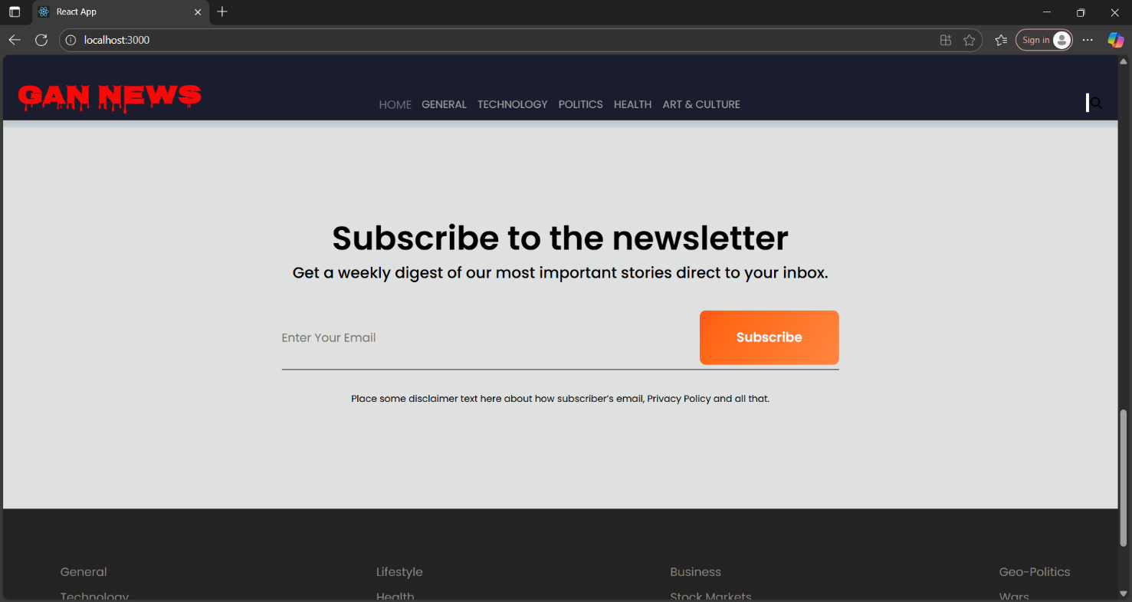

**Live Demo Link:**

# 13. Known Issues

* Certain API endpoints may have limited access for free plans

* Bookmark feature may require additional optimization for large data sets

# 14. Future Enhancements

* User Authentication for personalized news feeds

* Push Notifications for breaking news updates

* Enhanced Search with Filters by Date, Region, and Source

* Offline Mode for reading saved articles without internet access